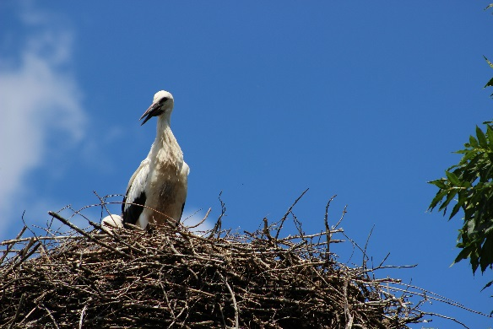

The 5Cs Summer 2014 Report

This summer marked the ninth year that The 5Cs have sent volunteers to the Belarusian Childrens Hospice summer camp in Zabrodia. The camp provides a much needed break for families and children under the care of the Hospice and is run by Hospice staff and a team of international volunteers.

Our volunteers make up part of this international team team that care for children, prepare activities and help with kitchen duties. In addition to these volunteers, The 5Cs also sends a larger group that help with maintenance of the camp, painting, digging and repairing- you name it!

Although we are involved in supporting many of the Hospice projects and fundraising to help cover the costs of opening the camp, this volunteer project is the largest programme that The 5Cs run each year. We provide volunteers for each session that the camp is open, a total of five 2 week sessions, this year totalling 26 volunteers over the 10 weeks.

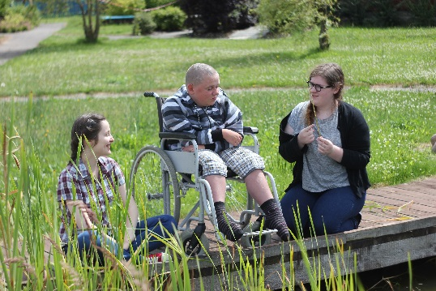Our volunteers are made up of final year students from local colleges in Cardiff that have applied for the programme for the first time and existing 5Cs members that are experienced volunteers in Zabrodia and are part of the team that run the charity throughout the year. We also have a team of very experienced volunteers that help to select and train new volunteers before they go to Zabrodia and then supervise and manage the project, along with the Hospice staff and volunteer coordinator, while they are there.

This summer our chair person, Beth stayed for the whole 10 weeks and two other supervisors, Zac and Daf, joined her for half the time each. Whereas in the past few years, the supervisors have stayed off the camp and joined in where needed, this year all three of them stayed on the camp and were part of the team for each group. This gave us a fantastic overview of the project from beginning to end and we feel it was beneficial in knowing how to further support the camp and volunteers in the future. Beth says “As exhausting as it was, it was very useful from a 5Cs point of view, I saw all the children, all the volunteers, all the problems we faced and was able to really review in what ways we can further develop the project and support everyone better. I was a volunteer on the team, assigned to a child, on the cleaning rotas and up all night preparing games and activities along with the other volunteers for all the groups- it was the biggest challenge of my life but also one of the best decisions I have made so far- I had the time of my life!”

We saw over 70 children and over 100 volunteers, coordinators, nurses, leaders, cooks, ambassadors, film crews, interviewers, translators, sponsors, builders, clowns and tri-athletes as well as countless other visitors over the course of ten weeks and five sessions.

As ever, both the 5Cs volunteers and the rest of the volunteer team were fantastic in helping to care for the children and preparing brilliant activities and games for them. We had themed days including underwater, Olympic, business, Spa, talent show, Eco, Christmas, even time travel! As well as the favourite National Days of the volunteers- this year ranging from Welsh (of course!) to Romanian, German and Belarusian. Some of the children that visit the camp need 24 hour care with many aspects of their lives, including showering, toileting and eating. All the volunteers do a great job- adapting to their role very quickly- most of them with no previous experience. Bearing in mind the 5Cs volunteers don’t speak Russian and not many of the children speak English, the way that they find creative ways of communicating and take everything in their stride never fails to amaze us. All of the groups were so close by the end that there were always lots of tears when the bus came to collect everyone to go home!

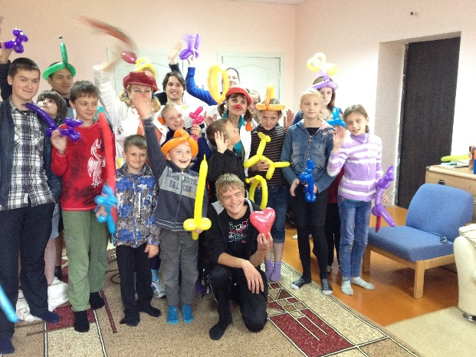

The first group were siblings- a very important Hospice project is the support of the siblings of sick children, and part of the programme is to invite 16 of them to the camp for the first session. As you can imagine it is more energetic and physically exhausting than some of the disabled groups, waking them up every morning dressed up and dancing to 90’s pop was particularly fun. We swam, ran, played football, walked to the village and the lake among many other things and they had a great time giving us Russian lessons! We even had a pet tortoise to look after while one boy’s family went on holiday- his name was Hank!

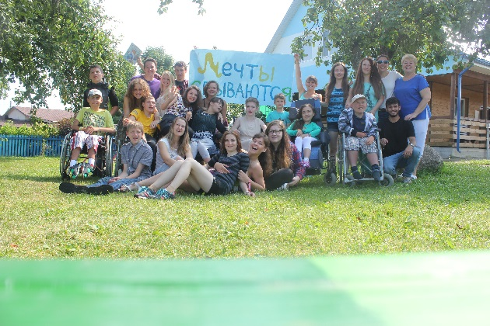Then along came group 2, the first disabled group of children. This group was one of the hardest physically that we have seen on the camp, with the volunteers- fantastic as ever- taking it in their stride and working round the clock. This group also brought us fame, with a film crew from a news channel visiting for the day, we put on a big show and bbq and were all interviewed for the news. We were stopped a few times in local villages after that to be told that local people had seen us on the tv!

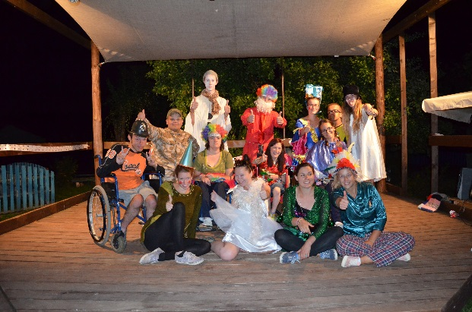Group 3 was slightly calmer, with the children being children that we have known since the beginning and older too, a different but equally as rewarding dynamic. Lots of dancing, shows, singing, long sunset walks to the lake, and lots of sunshine!

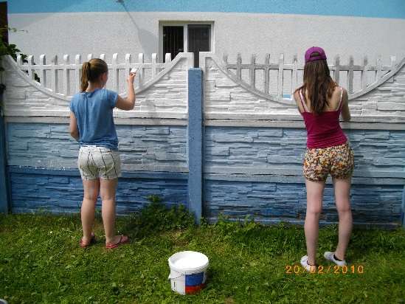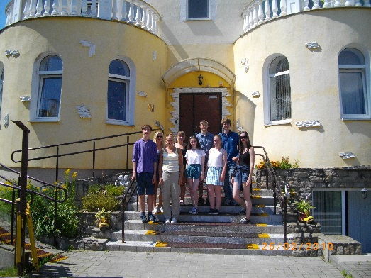Simultaneously to group 3, along came our big group of maintenance volunteers- 7 in total. They had great fun camping out in the family house on the camp, it is being worked on by builders at the moment but they kindly postponed so we could stay there and make use of the kitchen and bathroom. As ever they worked tirelessly in the heat, renewing the paint on almost all of the buildings for the winter, repairing and repainting the outside fences and many other jobs on the camp. Needless to say we were all covered head to toe in blue paint for the duration of the maintenance trip, but the smiles never left their faces and as a result the camp looks fantastic for another year!

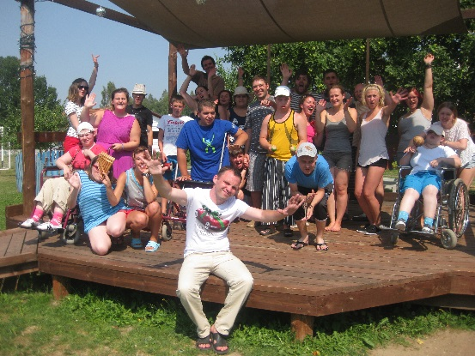

Group 4 then arrived, again a quite disabled group of children but the volunteers coped well again, with activity packed days and evenings- a particular favourite of ours being a new explorers day which saw the children travel the globe in one day!

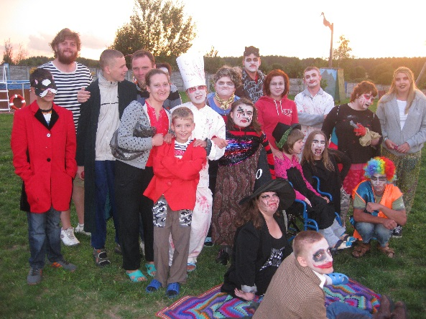

Group 5 brought a lot of rain, more energetic kids and more sponsors with another film crew- this time for the brilliant Anton Simon, an English man that had completed a triathlon in Minsk for the Hospice. We also enjoyed lots of films, inside fake campfires, inside discos and even a bit of time travel!

The camp is truly a magical place, a place we feel is life changing. The experience that all the volunteers and children share together there is completely unexplainable to anyone who has not experienced it and ties us all together. The volunteers and children alike become singers, dancers, performers, lifelong friends, support networks to each other and so much more. The 5Cs team are as strong as ever, we can’t quite believe it’s another year over, the third year we have run as a (not so now) new team!

One of our team leaders, Bethan Sexton, has spent three summers visiting the camp now and this year she wrote an article for an online blog, she says “It’s hard to communicate exactly what the experience was like in words and on paper, ‘Come to an Eastern European country and look after a disabled child who doesn’t speak your language’ doesn’t seem all that attractive, but like the country itself, there was so much more to the experience than meets the eye. A typical day on the camp will see you dress up at least 3 times in various costumes, dance to Russian electro-pop and perform some kind of show on the much-loved wooden stage, learning quickly that questionable dance moves transcend all language barriers. The camp is an all-singing, all-dancing bundle of happiness and undoubtedly one of my favourite places on earth.”

When talking about her trip to the Hospice in Minsk the year before, she says “Perhaps the most moving part of all was the hospice’s chapel, the walls of which acted as a memorial to those who hadn‘t made it. It made for hard viewing, but I felt compelled to look at the smiling faces of each of the children who‘d passed away, ranging from toddlers to people of my own age, having had little experience with death myself, it was difficult to comprehend that they were no longer here. Try as I might I don’t think I’ll ever be able to properly express the sorrow I felt at that moment, I‘d never felt so humbled and so far from home. It was only later when I looked back on that moment that I realised how trivial my own worries seemed, at the risk of sounding like a walking cliché, it really enabled me to re-examine my priorities and those three letters on a piece of exam board paper didn’t seem quite so significant.”

[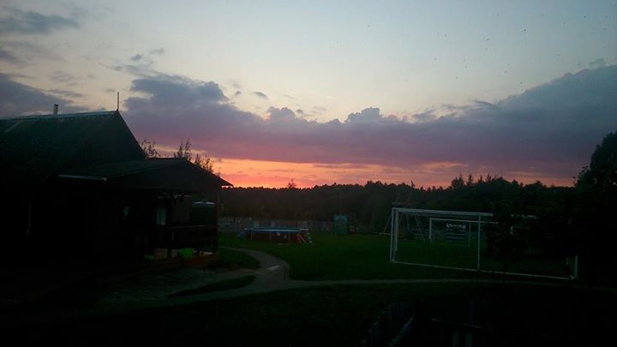](https://www.facebook.com/photo.php?fbid=10152682888080979&set=a.10150556513345979.428810.647320978&type=1)Now back in Cardiff, we have to get used to life back home again and try not to miss everyone too much. We love working with the Belarusian Children’s Hospice, the people we meet are among the most dedicated and special in the world and the joy we all get from being on the camp is enough to see us through to the next summer.

As the Hospice grows, with more and more families needing their help, the camp is also growing- and along with it, The 5Cs are growing… for the year 2014-15 we have a total of 55 on the committee made up of 8 trustees, 15 team leaders and 32 members! We are looking forward to having the honour of working with some of the most incredible and loyal young people around for another year.

Thank You to all our supporters and the people that stick by us to allow us to keep doing what we do, your support means the world to us.

Best wishes to you all

Beth, Zac and the rest of The 5Cs family, September 2014.